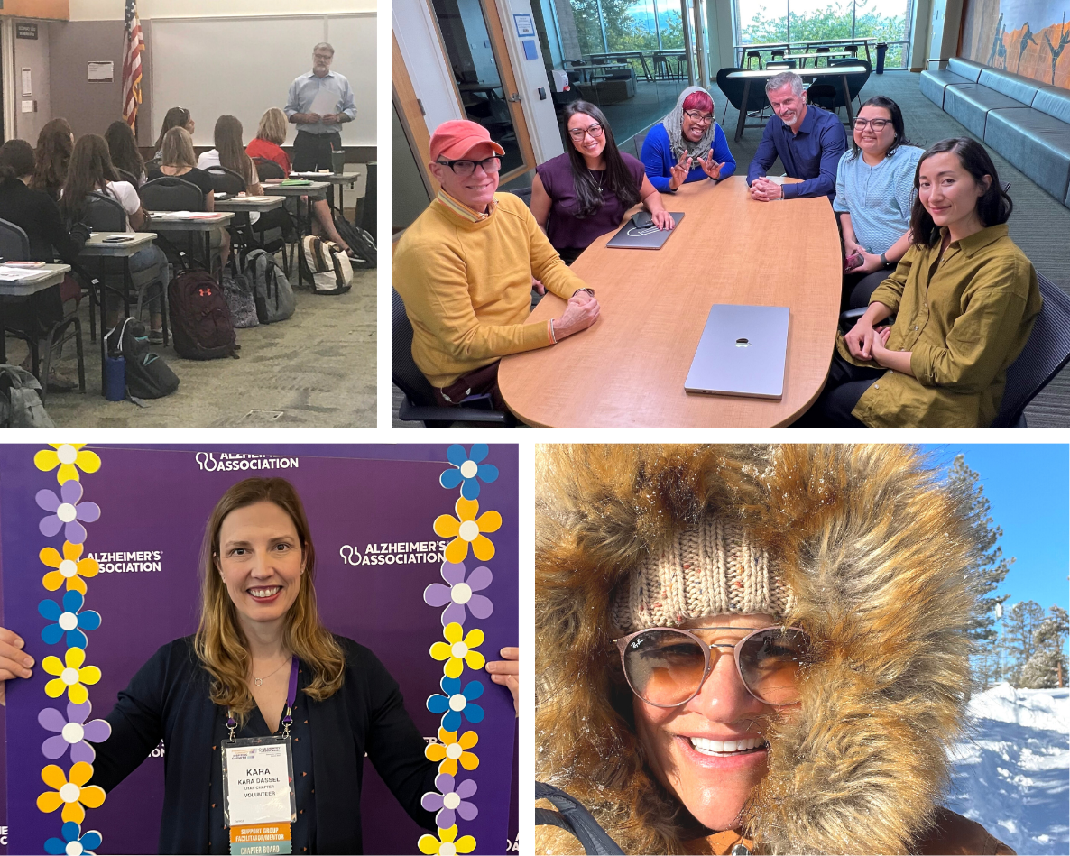
Email Photos to ConStrolls@nurs.utah.edu
February 6, 2023
Grant Award:
Team members Dr. Jackie Eaton, Dr. Katarina Friberg-Felsted, Dr. Rebekah Perkins, and Dr. Kara Dassel, and College of Nursing Excellence in Education (CONExEd) mentor Dr. Sara Hart received a $30,000 Teaching Innovation Team (TITe) intramural grant for their project titled Promoting Age Inclusivity to Enhance Educational Excellence within the University of Utah College of Nursing. Age inclusivity is an important aspect of meeting the needs of an aging population. In higher education, age

stratification is often reinforced in how faculty and staff view traditional vs. nontraditional students. Unfortunately, this reduces the ability of trainees to prepare to work with older adults upon graduation. Age inclusivity has positive outcomes for learning, including improving health, reducing social isolation, and decreasing ageism. The College of Nursing (CON) is an important setting to innovate age inclusivity because of longstanding collaborations across nursing and gerontology and the strong commitment to equity, diversity, and inclusion. The team will enhance educational excellence in the College by 1) conducting a needs assessment of age inclusivity, 2) developing training opportunities to improve age inclusivity, and 3) applying for Gerontology Interdisciplinary Program accreditation.
Professional Service:
Dr. Djin Tay (CON assistant professor, and former post-doctoral fellow in the Ellington lab) and Dr. Katherine Doyon (CON adjunct instructor, CON alumna, former CON Interdisciplinary Training in Cancer, Aging, and End-of-Life Care T32 pre-doctoral fellow, and assistant professor at Boise State University) contributed to the Hospice & Palliative Nurses Association’s (HPNA) 2023-2026 Research Agenda. By consulting with HPNA’s members and assessing major trends in hospice and palliative nursing, they and other colleagues identified knowledge gaps and identified five priority areas that require further scientific inquiry: 1) equitable palliative care (led by Dr. Doyon); 2) local, national, and global disaster/emergency response in palliative and hospice care (led by Dr. Tay); 3) pediatric hospice and palliative care research; 4) well-being of hospice and palliative care clinicians: self-care and workforce development; and 5) transitions in care. Collectively, the contributions highlight how College of Nursing faculty are working to advance social justice, equity, diversity, and inclusion in palliative care research.
Publication:
Meek PM, Schmiege SJ, Sood A, Petersen H, Vazquez-Guillamet R, Irshad H, McDonald J, and Tesfaigzi Y. Testing of a novel questionnaire of Household Exposure to Wood Smoke. PLOS Glob Public Health. 2023;3(1): e0001500. https://doi.org/10.1371/journal.pgph.0001500
Community Engagement:
Aarohi Drabu, Mikayla Dalley, Emilee Cluff, and student Nelson Kudilil hosted a table at the Granite Technical Institute (GTI) Career and Technical Education Open House, and spoke with students who are interested in a career in nursing or health care. These staff members connected with certified nursing assistant and other students, including those from groups that have been historically excluded and underrepresented in nursing, and discussed pathways by which GTI students can pursue nursing education.

Dr. Larry Garrett presented a daylong transitions of care seminar at the Southern Utah University Department of Nursing. Content featured students conducting home visits for patients recently discharged from the hospital, and learning coaching, Teach-Back methods, and other nursing skills based on the Care Transitions Intervention model. In partnership with Southern Utah University, Dr. Garrett has taught this seminar for each incoming class of nursing students for the past five years. To date, more than 500 nursing students have attended the seminar.
Award:
The Healthcare Information and Management Systems Society (HIMSS) presented the HIMSS Most Influential Women in Health IT Award to adjunct assistant professor Dr. Victoria Tiase.
Faculty Spotlight:
Dr. Jia-Wen Guo was the College of Nursing’s Clean Air Champion in January. She uses public transportation five days per week. To make commuting easier, Jia-Wen uses the Utah Transit Authority’s GoRide and Transit apps to track bus and TRAX schedules.
Kudos will not be published on February 20, 2023.
Best Regards,
Marla

